Chapter 11, Solution 78.

Find the wattmeter reading of the circuit shown in Fig. 11.93 below.

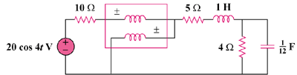

Figure 11.93
For Prob. 11.78.

Solution

The wattmeter reads the power absorbed by the element to its right side.
,

Consider the following circuit.

Z

10

200 V
+

I

